23.28: a) 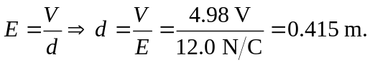
b) 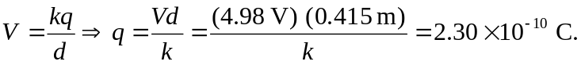
c) The electric field is directed away from q since it is a positive charge.

